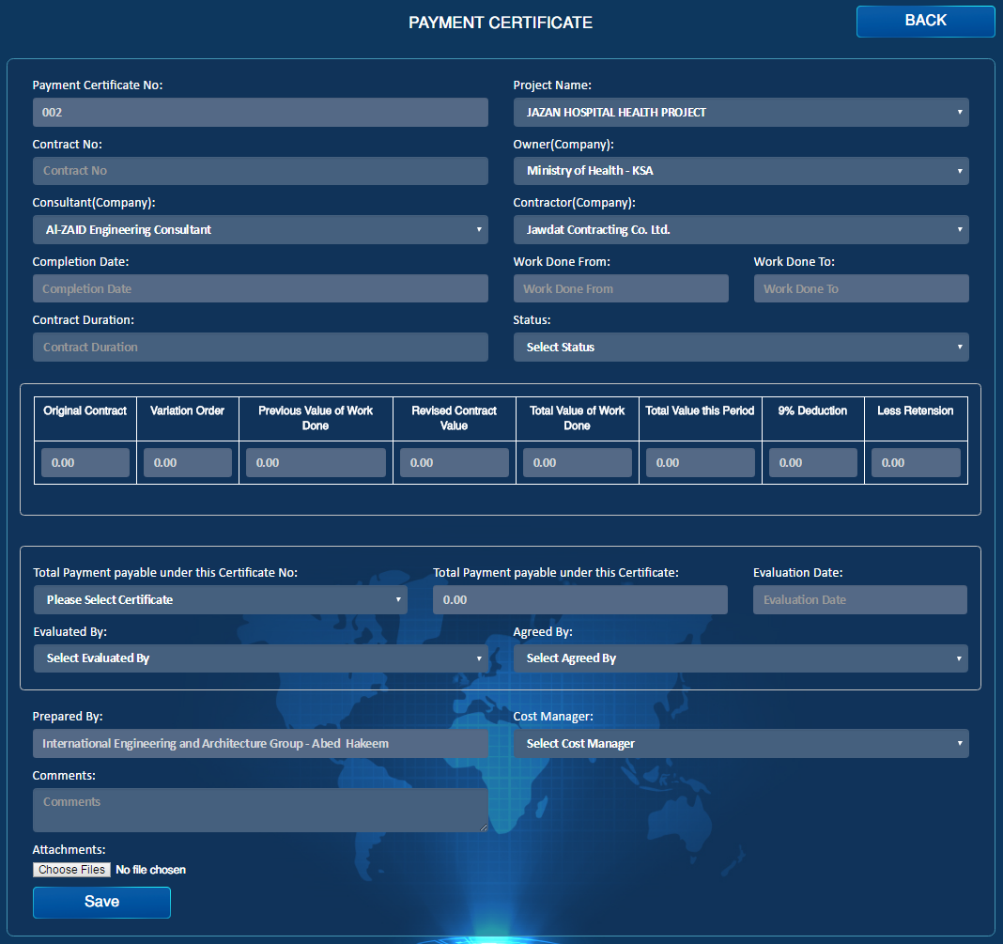

Contract

Import

MR #

Import

PO#

Import

Transmittal Letter

Import

Email

Import

PDF

Import

Reject

Import

Approve

Import

Draft

Import

Submit

Import

Auto

Auto

Auto

Auto

Auto

Auto

Auto

Auto

Auto

Fixed Date from Contract

Fixed Date from Contract

Auto

Auto

Auto

Auto

Auto

Auto

Auto

1. PO# & MR# will be automatically populated in case the contract was purchase Order
2. In Less Retention field, percentage in the formula will be equal to the percentage given in the Contracts form

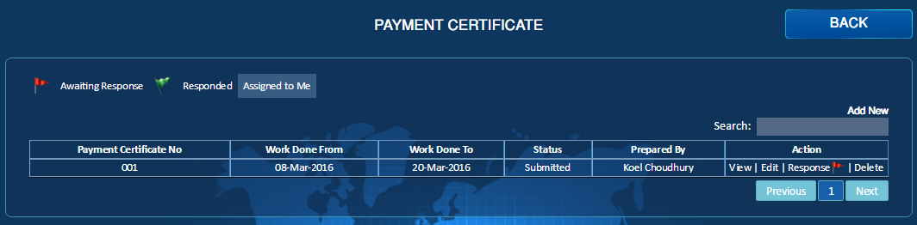

Category

Import

Contract

Import

1. Filter by Category & Contract are required.